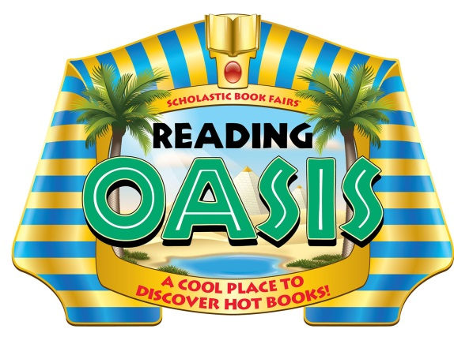

Dear Parents and Families:

Reading is the most important skill you can teach a child. Of all the skills children learn, it is the one you can influence the most.

We invite you to visit our Scholastic Book Fair® and experience a celebration of reading that provides families the opportunity to get involved in a universal mission: encouraging kids to read every day so they can lead better lives.

Our Scholastic Book Fair theme – Reading Oasis: A Cool Place to Discover Hot Books! – takes students on a journey back to Ancient Egypt to an oasis overflowing with a treasure of fun, engaging, and affordable books kids want to read. Giving kids access to good books and the opportunity to choose their own books will motivate them to read more. And like most acquired skills, the more kids practice reading, the better they’ll get.

Reading is vital to every child’s success, and raising kids as readers means getting involved while they’re young. Now is the time. Since there will never be a substitute for a parent’s direct involvement in his/her child’s education, please make plans to visit our Book Fair. Hope to see you there!

Book Fair Dates: October 7th – October 11th

Sincerely,

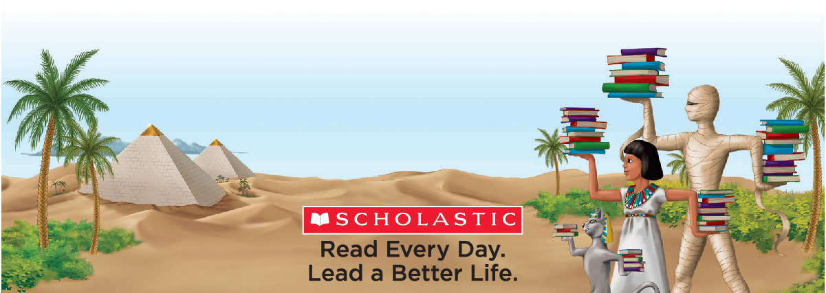
Mrs. Scarpella
© 2013 Scholastic Inc. 10921 • 131201
Mesa Elementary Library Media Specialist

